Being Human, Being happy

An analysis of the correlation amongst variables in Gallup’s World Happiness Report and their relative impact on happiness.

July 14, 2019

Vikram Kumar, Sapan Sharma, Sara Wilson

Data Programming in R | MSCI:6060:EXP | Sum2019

# Being Human, Being Happy

## Purpose

The purpose of this analysis is to understand what most impacts happiness across the globe. In order to answer this question, data was reviewed from the 2019 Gallup World Happiness Report. Six key variables were identified and their correlations amongst each other and against the dependent variable (the Happiness Index) were measured.

There are six key variables (independent variables) explained below which are being used to explain life evaluations or the Happiness Index (dependent variable). These six variables are highlighted as the most important in identifying differences between the life evaluations across countries. The report points out that some important variables like unemployment or racism are not included “because comparable international data are not yet available for the full sample of countries” ( https://worldhappiness.report/faq/ , 2019).

1. **GDP per Capita**: the nation’s gross domestic product, or the “health” of a country’s economy, over its population. This is taken from the 2018 update of the World Development Indicators (WDI).
2. **Social Support**: the national average of the binary responses (either a 0 or 1) to the GWP survey question “If you were in trouble, do you have relatives or friends you can count on to help you whenever you need them, or not?”
3. **Healthy Life Expectancy (HALE)**: according to the World Health Organization, the number of years of good health a newborn can expect. Overall global HALE at birth in 2016 for males and females combined was 63.3 years, 8.3 years lower than total life expectancy at birth. In other words, poor health resulted in a loss of nearly 8.3 years on an average globally.
4. **Freedom**: the national average of the binary response to the GWP question “Are you satisfied or dissatisfied with your freedom to choose what you do with your life?”
5. **Generosity**: the residual of regressing the national average of GWP responses to the question “Have you donated money to a charity in the past month?” on GDP per capita.
6. **Absence of Corruption**: perception of corruption is the average of the binary answers to two GWP questions: “Is corruption widespread throughout the government or not?” and “Is corruption widespread within business or not?”

## Analysis and Conclusion

For this analysis we created a correlation plot using the six key variables and the Happiness Index (see Figures 1 and 2). GDP per capita has the highest correlation (0.79) to a country’s Happiness Index while, surprisingly, perception of generosity has the lowest correlation (0.08) of the variables. Life expectancy and social support (0.78) were also strongly positively correlated to the Happiness Index, followed by freedom to make choices (0.57), perception of corruption (0.39) and finally generosity (0.08). The strongest correlation among the variables is between GDP per capita and life expectancy (0.84).

Happiness_Index BaseLine_Score GDP_Per_Capita Social_Support

Happiness_Index 1.00 0.47 0.79 0.78

GDP_Per_Capita 0.79 -0.03 1.00 0.75

Social_Support 0.78 0.03 0.75 1.00

Life_Expectancy 0.78 -0.01 0.84 0.72

Freedom_to_MakeChoices 0.57 0.08 0.38 0.45

Perception_of_Curruption 0.39 -0.01 0.30 0.18

Generosity 0.08 -0.05 -0.08 -0.05

Life_Expectancy Freedom_to_MakeChoices Generosity Perception_of_Curruption

Happiness_Index 0.78 0.57 0.08 0.39

GDP_Per_Capita 0.84 0.38 -0.08 0.30

Social_Support 0.72 0.45 -0.05 0.18

Life_Expectancy 1.00 0.39 -0.03 0.30

Freedom_to_MakeChoices 0.39 1.00 0.27 0.44

Perception_of_Curruption 0.30 0.44 0.33 1.00

Generosity -0.03 0.27 1.00 0.33

Figure 1

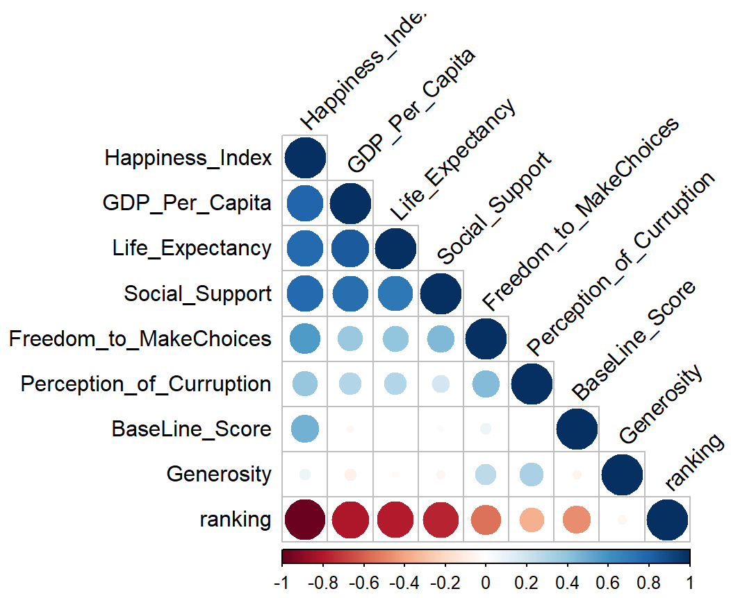

Figure 2

From here we created a quick output of the top 10 countries by Happiness Index. We then created a function to extract values for each of the features for the country defined (see Appendix). This allowed us to quickly confirm that high a Happiness Index aligned with high perceptions of GDP per capita, life expectancy, and social support (see Figure 3).

## 

## 

Figure 3

Finally,

## Data Gathering and Preparation

The World Happiness Report is a compilation of data from the Gallup World Poll (GWP)

which measures the state of global happiness, ranking 156 countries by their citizens’

perceived happiness. The data was read into R Studio using readxl after downloading the data from <https://s3.amazonaws.com/happiness-report/2019/Chapter2OnlineData.xls>.

The original report was available as an Excel workbook with three tabs. Different parts of our analysis required data from different tabs and so for each inquiry we imported directly using “readxl : : read_excel….” so that we could specify which sheet we required each time. The data was very clean and did not require any imputation or manipulation. On reading in the data, however, we did remove unnecessary columns and rename columns for improved readability.

APPENDIX

* An appendix with documentation of the R function written to assist your analysis.